NFED FAMILY-DRIVEN ADVOCACY
CALL TO ACTION

Step 2: Contact your legislators
Now that we have Senator Tammy Baldwin in our corner, we need to contact all our legislators, educate them and ask for their support. This is an important step in our process to garner support for federal legislation. Everyone needs to participate! Share with your family and ask them to send this letter to their legislators as well. There are strength in numbers and the more letters that are received the more our voices will be heard!

Please mail or email letters to your legislators by July 19, 2017.

Find the contact information for your legislators.
Contact your legislator by mail or email in advance of Advocacy Day. Let them know you will be part of Advocacy Day on July 19, 2017 with the NFED and other NFED families affected by ectodermal dysplasias. If you don’t know who your legislators are (you have two senators and one representative), do the following:

U.S. Senate
- Go to: www.senate.gov.
- Top left, click on Senators.
- Top left, choose your state and click. You will see your two U.S. senators for your state.

U.S. House of Representatives
  - Go to: www.house.gov.
  - Top right says FIND YOUR REPRESENTATIVE. Enter your zip code and click GO.
  - The name of your U.S. Representative for your state district will appear at top left side of page.

See second page to write your letter.

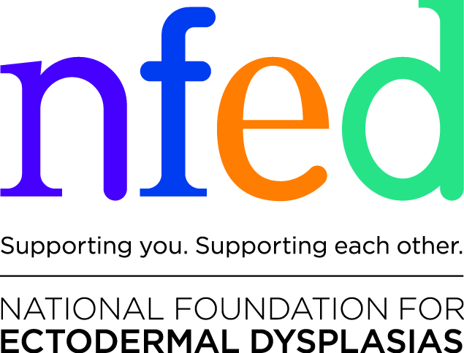

Write Your Letter

Attendees:
- Prior to your visit, email or mail to your TWO senators, your ONE representative.
- Print and bring 4 copies of your personal story letter as a leave behind, one for each of your three legislators, and one for NFED.

(Your Name)
(Your Address)
(Your Email)
(Your Phone)
(Date)

Office of Senators (NAME), (NAME)
United States Senate
Washington, D.C. 20510
https://www.senate.gov
(202) 224-3121

Office of Representative (NAME)
U.S. House of Representatives
Washington, DC 20515
http://www.house.gov
(202) 224-3121

Dear Senators (NAME), (NAME), Representative (NAME),

Thank you for the opportunity to meet with you on July 19, 2017 with the National Foundation for Ectodermal Dysplasias (NFED) and other NFED families affected by ectodermal dysplasias. We need your help to get a federal law passed to protect us.

Ectodermal dysplasia is a rare congenital anomaly that affects less than 1 birth in 10,000. People born with ectodermal dysplasia lack the ability to properly develop and grow hair, nails, mammary glands, sweat glands and TEETH. When a person lacks two or more of these body parts, they are diagnosed with ectodermal dysplasia. It is the extensive problems with TEETH (no teeth, many absent teeth, defective teeth, missing or diminished bone to hold TEETH) that we are here today.

Although many states already have health insurance laws that mandate medical benefits to people who lose their “sound natural teeth” due to accidental injury (i.e. a car wreck), they auto-deny those benefits for people like us whose accident, happened in-utero. Many states also have laws that mandate medical benefits to “people born with a congenital anomaly and resultant missing/defective body parts”. Yet insurance companies (and many self-funded plans that contain these benefits) willfully auto-deny necessary medical care and treatment for TEETH resulting from congenital anomaly—a body part.

Again, we need your help. Senator Tammy Baldwin of Wisconsin is helping us raise awareness for Ectodermal Dysplasias and introducing a Senate Resolution. Please join her and support our families. We need a federal law that will mandate health insurance companies and employer sponsored self-insured health benefits plans cover congenital anomalies and birth abnormalities from the moment of birth as an injury or sickness, covering the functional repair or restoration of any body part, including the TEETH and bone that holds the teeth, when necessary to achieve normal bodily function.

Sincerely,

________________________________________
(YOUR NAME HERE) (SIGN ABOVE)

